NOVEMBER 2020 Newsletter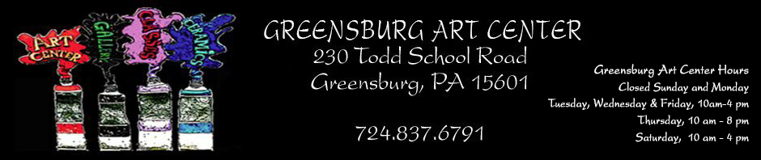
Join Us For a Sculpture Garden Party
August 4 1-4:00 PM
See Brian McCall install an original
sculpture he created on the art center grounds.
The public is invited to enjoy free refreshments and fun at the Greensburg Art Center

The Artist Market and Gift Shop
are open to the public!

The Art of GIFTING Exhibition and Sale

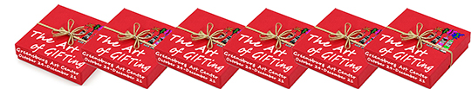

Now until- December 21, 2020



Art Contest for Classroom Exhibit

WINNERS:
First Place: Peg Panasiti, SEASON OF LIGHT
Second Place: Joni Rozell, CANDLES BRIGHT
Third Place: Pat Majcher, RADIANCE
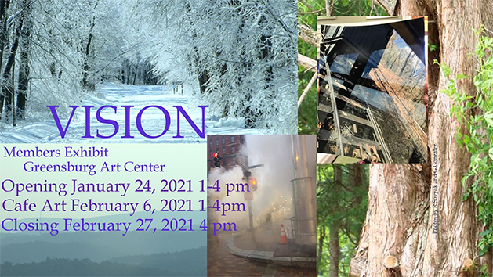
MEMBER SHOW
The annual “MEMBER SHOW” is in the planning stages. The theme is “VISION”. Entries are due Friday, January 11. The prospectus will be available November 4.

******************************************************************
SPECIAL THANKS
Thanks to the following Donors: Jerry Scorpion, Doris Wood, Janice Decker, Priscilla Richardson, and H.K. Miller.
DONATIONS–For all of you who love the Greensburg Art Center, kindly donate via PayPal or at greensburgartcenter.org or Call 724-837-6791 or Mail your contribution to Greensburg Art Center, 230 Todd School Road, Greensburg, PA 15601.
Rowe Memorial Garden A special garden area in memory of Kay and Bill Rowe was designed by Patty Schildkamp, a Master Gardener. It will include a path leading to a bench, a boulder with dedication plaque, perennials and annuals. After the holidays GAC will have a donation drive to contribute to this effort.
****************************************************************************************
CONDOLENCES to Maura Koehler Keeney on the death of her father, Herbert G. Koehler Jr. The boxwoods lining the walks and building at the Art Center were propagated and donated by Herb. Thank you to his family for asking that Memorial Donations be made to Greensburg Art Center.
****************************************************************************************
EDUCATION: The fall classes have been running smoothly with precautions taken. Covid Guidelines are being followed. One remaining and ever popular class that’s left on the schedule is “Mosaics with Rose” Friday, November 13, 4-7pm. $40 includes materials. Be sure to check out the full schedule on the web site greensburgartcenter.org.
****************************************************************************************
Annual membership dues are due by December 31.
Any dues paid recently and through December 31 will be for membership to the end of 2021.
- Individual – $40. Family – $70. Student (college) – $25. Artist Market – $40

****************************************************************************************
CORRESPONDENCES SECRETARY’S REQUEST
Please send information for get well, sympathy, thinking of you, etc. cards to Barbara Park at Greensburg Art Center, 724-837-6791 or messenger on GAC web page. Thanks to Barbara for taking on this responsibility.
****************************************************************************************
MEMBER MEETING on November 9, 7PM. We Welcome ALL to this information event.
ELECTIONS OF OFFICERS
The officers of Greenburg Art Club are responsible for guiding the Art Center to remain a welcoming and nurturing place for artists of all ages and abilities.
On November 9 the membership will vote on a candidate for each office. The new officers will take charge January 1, 2021.
****************************************************************************************
Monitor Manager
Loretta Wolfe is scheduling the volunteers and finding substitutes when necessary. If you are interested in helping GAC by agreeing to take ONE 3-hour shift a month, she can be reached at 724-691-1523 or at eflow26@aol.com.
****************************************************************************************
DARKROOM Rental – Available are several enlargers and the necessary trays, sink, safe light, timers, etc. Chemicals are NOT included in the rental cost. Photo paper is FREE. Bring your materials and have fun developing! Cost: $5/3 hours $25/Week INTERESTED? Contact: Shirleah Kelly 412-915-0301 or Shirleah1@aol.com
****************************************************************************************
INSTAGRAM To view GAC on Instagram, go to Instagram.com, download the free app, and type in greensburgartcenterandgallery (all one word) in the “Search” box at the top of the page. For our members who want to share their work and be shown as a member of GAC, please send photos and comments in an email to jkmoreno@msn.com. Those teaching classes or organizing other activities at GAC can do the same. Questions? Please email or call Jacki at 412 977-4323.
****************************************************************************************
HOSPITALITY GIFT SHOP IN WESTMORELAND HOSPITAL Contact rosemarysovyak@gmail.com or 412-558-0810 if interested in future displays.
****************************************************************************************
Opportunity for Artist Market Members Only: GAC is accepting “Small Works. For guidelines, please go to https://www.greensburgartcenter.org under Artist Market. Watch for more details in e-mails and Facebook.
****************************************************************************************
PHASE III TO HONOR SPECIAL PEOPLE IN OUR LIVES AND … BEAUTIFY GAC GROUNDS.
You are invited to have a living testament of your love for very special people in your lives. Trees (and selected shrubs) will include ground markers” In Honor of” or “In Memory of” for the person(s) you select. Gifts of this type start at $50. Payments can be made by check, credit card, or PayPal. PRICES INCLUDE PLANTING AND PLAQUES.
****************************************************************************************
VOLUNTEERS NEEDED
STANDING COMMITTEES IN NEED OF NEW VOLUNTEERS – If you have even a little bit of time and can help sporadically, we could use some new faces for these Committees – Gallery (extra hands to install exhibits, do mailings, handle receiving and pickup, set up for openings, and refreshments), and Facilities help.
CALL for TEACHER–Lithograph Teacher needed at GAC. Call Pat Majcher, Nancy Delverny or Shirleah Kellly– Edu Committee.
****************************************************************************************
EXHIBITION OPPORTUNITIES
The Westmoreland Museum of American Art: Call for op-Up Exhibition Proposals. The Westmoreland is accepting proposals for Pop-Up Exhibitions, which are held in the Robertshaw Gallery (adjacent to the lobby on the 1st floor). Artists working in all media will be considered. Site-specific installations are welcome. Guidelines for submitting proposals are available at: www.thewestmoreland.org/about/opportunities.
Art Show @ Pitt-Greensburg
The 4th Annual Art Show @ Pitt-Greensburg was virtual! Winners from GAC are the following:
FAN FAVORITE–Second Place, Rose Sovyak. “AFRICAN SUNSET”
PHOTOGRAPHY–Third Place, Suzanne Panchura “FIRE & ICE”
PAINTING– Third Place, Marcia Koynok “PORTRAIT OF KYLE”
****************************************************************************************
Monitors–ATTENTION: THE BLUE GARBAGE CAN IN THE KITCHEN IS FOR RECYCLING ONLY. IT Should be put out every MONDAY for Tuesday pickup.
****************************************************************************************
Newsletter Submissions to Shirleah1@aol.com. NOTE: November 27 is the final submission date for December’s News. Copies are available in the office area at GAC.

